Niranjan S-JUnit, Mockito and SL4J
1) JUnit Testing Exercises
Exercise 1: Setting Up Junit
Pom.xml:
<dependencies>

<dependency>
<groupId>junit</groupId>
<artifactId>junit</artifactId>
<version>4.13.2</version>
<scope>test</scope>
</dependency>

</dependencies>
Calculator.java:
package com.example;

public class Calculator {

public int add(int a, int b) {
return a + b;
}
}
CalculatorTest.java:
package com.example;
import org.junit.Test;
import static org.junit.Assert.*;
public class CalculatorTest {

@Test
public void testAdd() {
Calculator calc = new Calculator();
int result = calc.add(10, 20);
assertEquals(30, result);
}
}
Output:
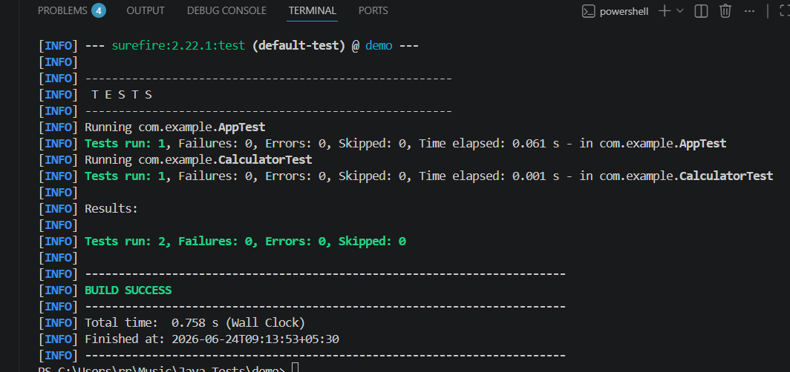

Exercise 2: Writing Basic JUnit Tests
Output:
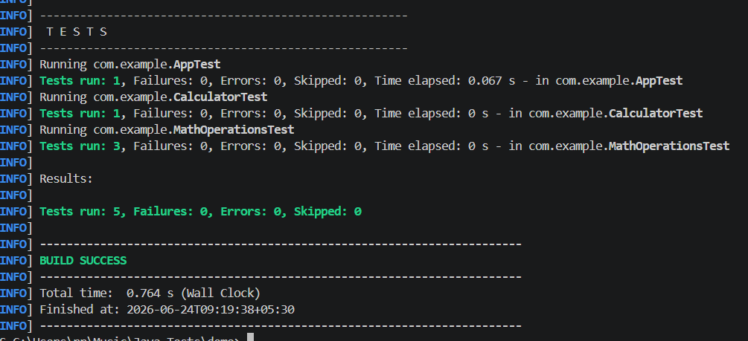

Exercise 3: Assertions in Junit
AssertionsTest.java:
package com.example;
import org.junit.Test;
import static org.junit.Assert.*;
public class AssertionsTest {
@Test
public void testAssertions() {
assertEquals(5, 2 + 3);
assertTrue(5 > 3);
assertFalse(5 < 3);
assertNull(null)
assertNotNull(new Object());
}
}

Output:
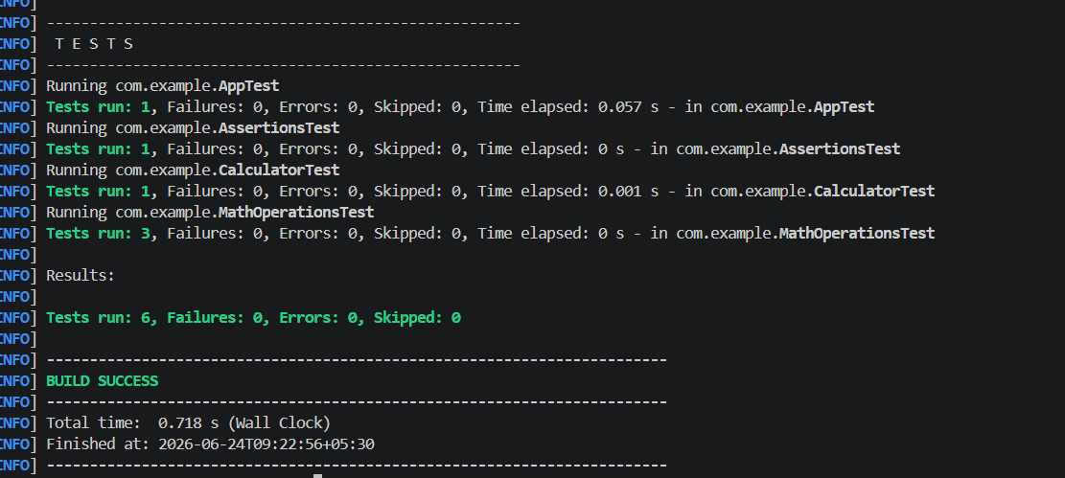

Exercise 4: Arrange-Act-Assert (AAA) Pattern, Test Fixtures, Setup and Teardown Methods in Junit
AAATest.java:
package com.example;
import org.junit.Before;
import org.junit.After;
import org.junit.Test;
import static org.junit.Assert.assertEquals;
public class AAATest {
private Calculator calculator;
@Before
public void setUp() {
System.out.println("Setup: Creating Calculator Object");
calculator = new Calculator();
}
@After
public void tearDown() {
System.out.println("Teardown: Cleaning Resources");
calculator = null;
}
@Test
public void testAddition(
int a = 10;
int b = 20
int result = calculator.add(a, b)
assertEquals(30, result);
}
}
Output:
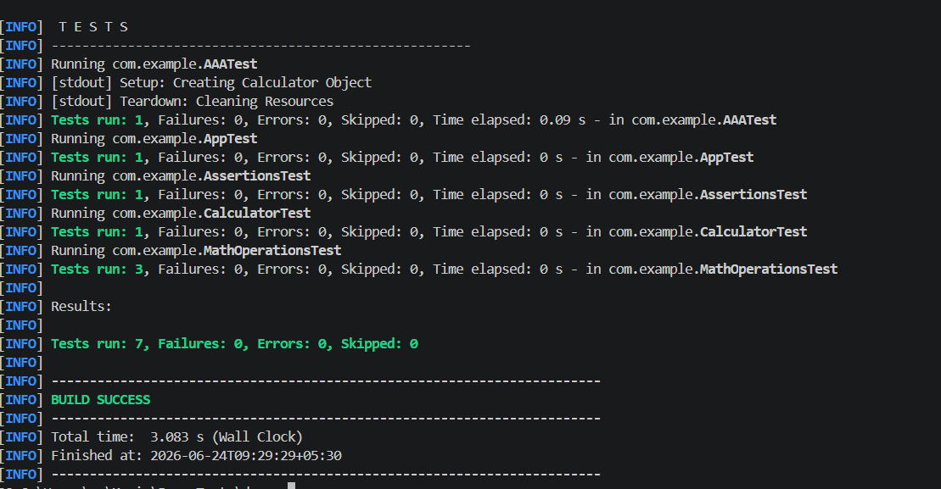
2) Advanced JUnit Testing Exercises
Exercise 1: Exercise 1: Parameterized Tests
Output:
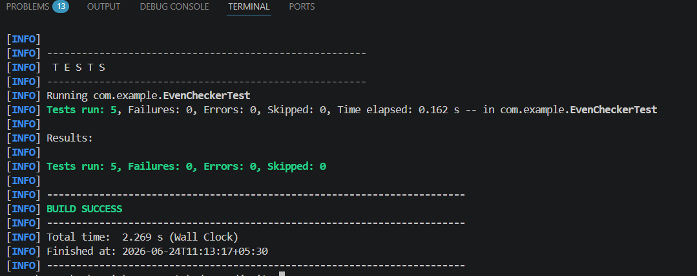

Exercise 2: Exercise 2: Test Suites and Categories
Output:
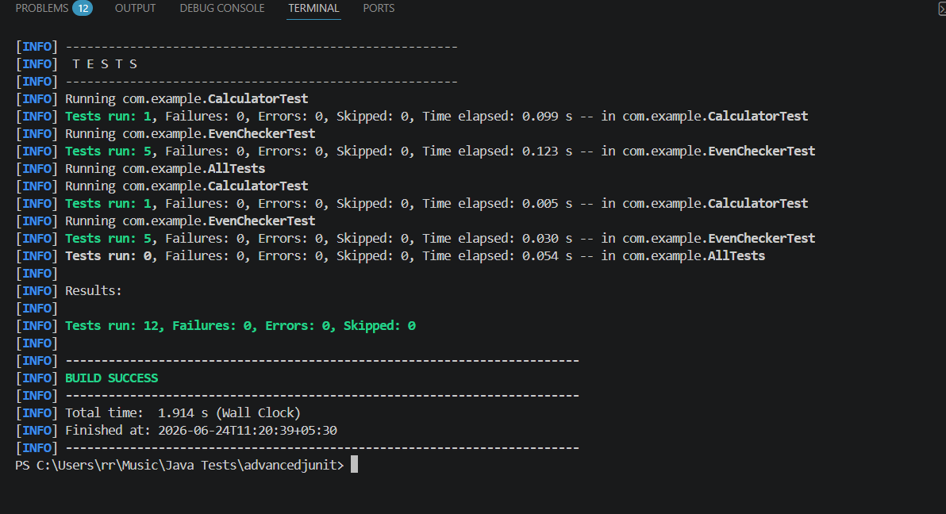

Exercise 3: Exercise 3: Test Execution Order
Output:
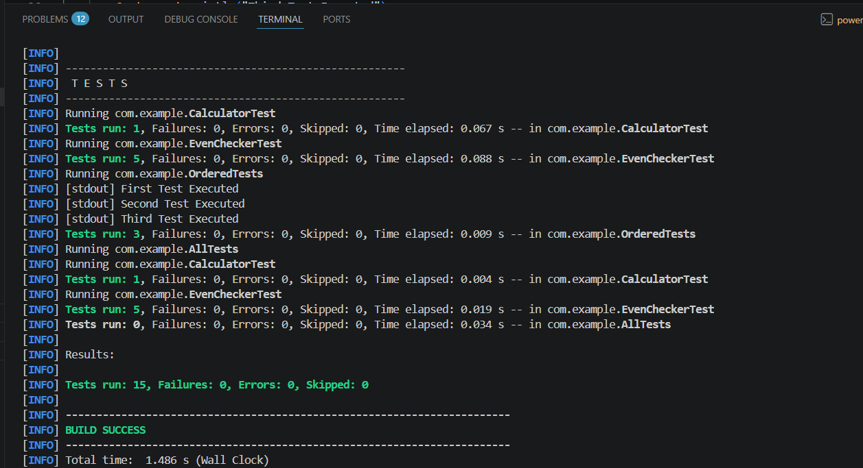

Exercise 4: Exception Testing
Output:
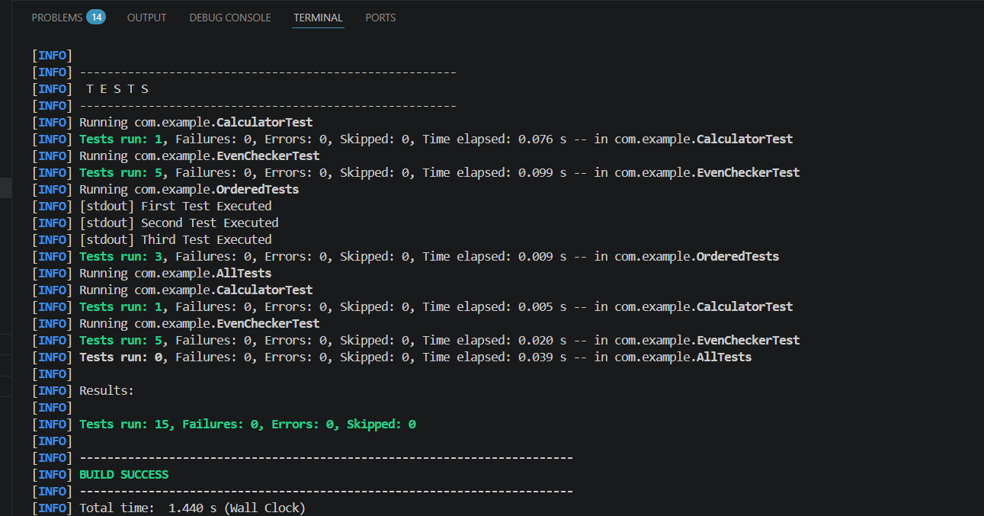

Exercise 5: Timeout and Performance Testing
Output:
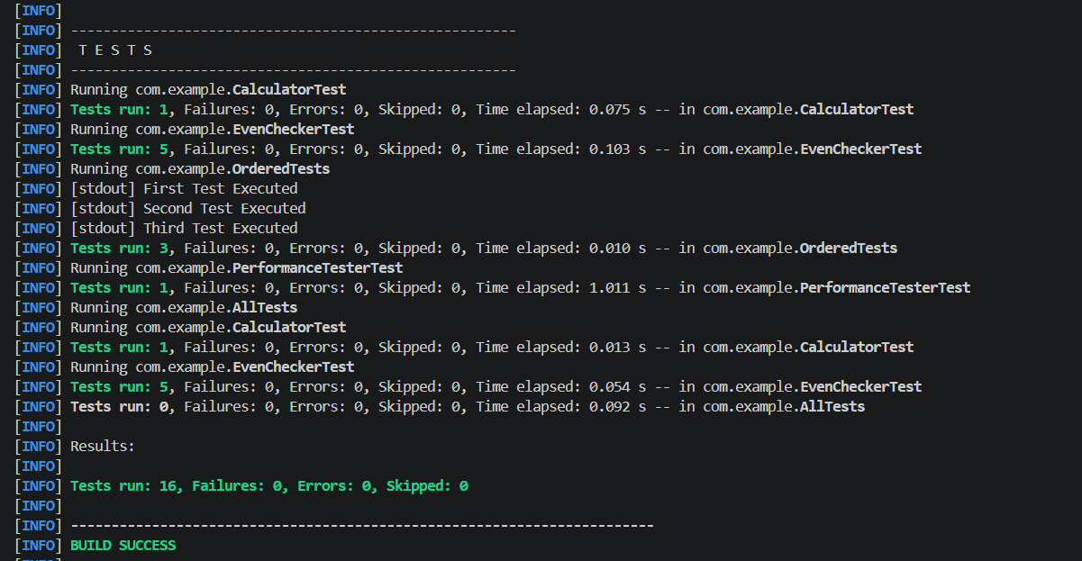

3)Mockito Hands-On Exercises
Exercise 1: Mocking and Stubbing
Pom.xml:
<project xmlns="http://maven.apache.org/POM/4.0.0"
xmlns:xsi="http://www.w3.org/2001/XMLSchema-instance"
xsi:schemaLocation="http://maven.apache.org/POM/4.0.0
http://maven.apache.org/xsd/maven-4.0.0.xsd">
<modelVersion>4.0.0</modelVersion>
<groupId>com.example</groupId>
<artifactId>mockitodemo</artifactId>
<version>1.0-SNAPSHOT</version>
<properties>
<maven.compiler.source>17</maven.compiler.source>
<maven.compiler.target>17</maven.compiler.target>
</properties>
<dependencies>
<dependency>
<groupId>org.junit.jupiter</groupId>
<artifactId>junit-jupiter</artifactId>
<version>5.10.2</version>
<scope>test</scope>
</dependency>
<dependency>
<groupId>org.mockito</groupId>
<artifactId>mockito-core</artifactId>
<version>5.12.0</version>
<scope>test</scope>
</dependency>
</dependencies>
</project>ExternalApi.java:
package com.example;
public interface ExternalApi {
String getData();
}
MyService.java:
package com.example;
public class MyService {
private ExternalApi api;
public MyService(ExternalApi api) {
this.api = api;
}
public String fetchData() {
return api.getData();
}
}
MyServiceTest.java:
package com.example;

import static org.junit.jupiter.api.Assertions.assertEquals;
import static org.mockito.Mockito.when;
import org.junit.jupiter.api.Test;
import org.mockito.Mockito;
public class MyServiceTest {
@Test
public void testExternalApi() {
ExternalApi mockApi = Mockito.mock(ExternalApi.class);
when(mockApi.getData()).thenReturn("Mock Data");
MyService service = new MyService(mockApi);
String result = service.fetchData();
assertEquals("Mock Data", result);
}
}

Output:
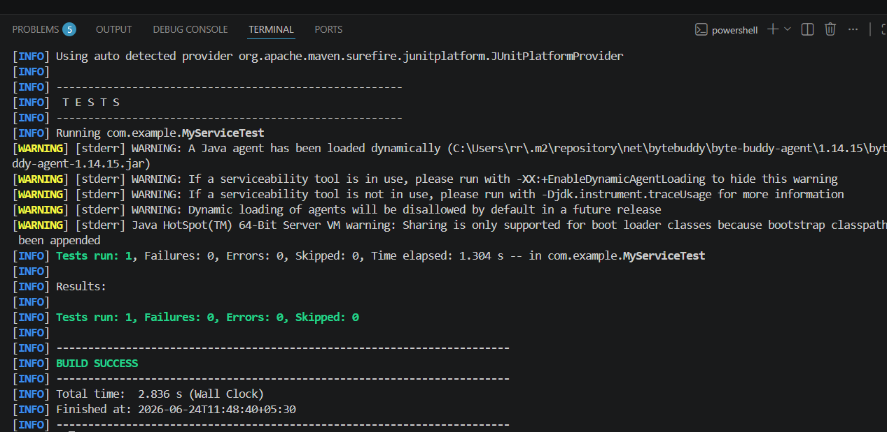
Exercise 2: Verifying Interactions
MyService.java:
package com.example;
import static org.junit.jupiter.api.Assertions.assertEquals;
import static org.mockito.Mockito.when;
import static org.mockito.Mockito.verify;
import org.junit.jupiter.api.Test;
import org.mockito.Mockito;
public class MyServiceTest {
@Test
public void testExternalApi() {
ExternalApi mockApi = Mockito.mock(ExternalApi.class);
when(mockApi.getData()).thenReturn("Mock Data");
MyService service = new MyService(mockApi);
String result = service.fetchData();
assertEquals("Mock Data", result);
}
@Test
public void testVerifyInteraction() {
// 1. Create the mock object
ExternalApi mockApi = Mockito.mock(ExternalApi.class);
MyService service = new MyService(mockApi);
service.fetchData();
verify(mockApi).getData();
}
}
Output:
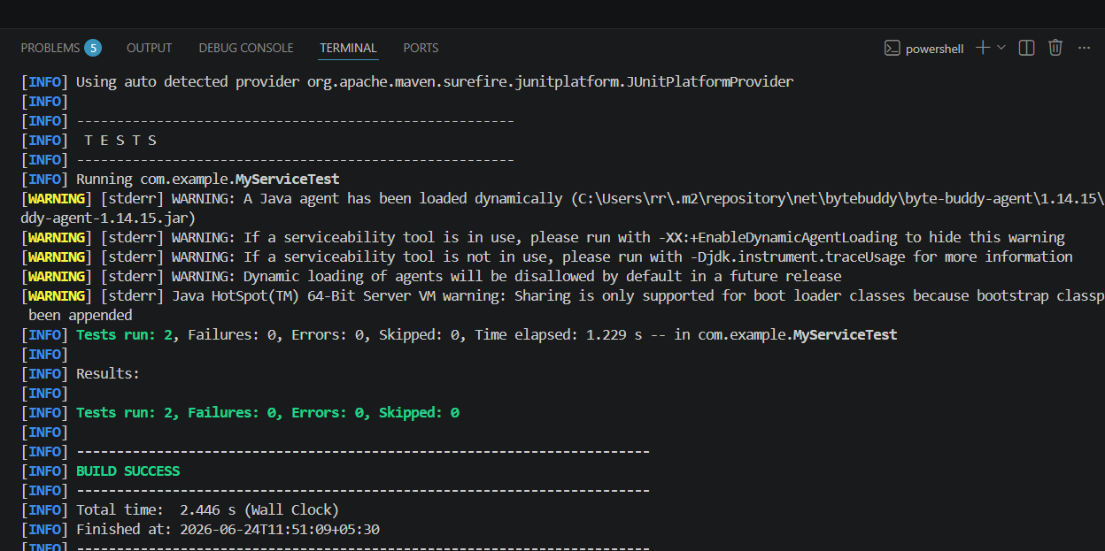
Exercise 3: Argument Matching
Output:
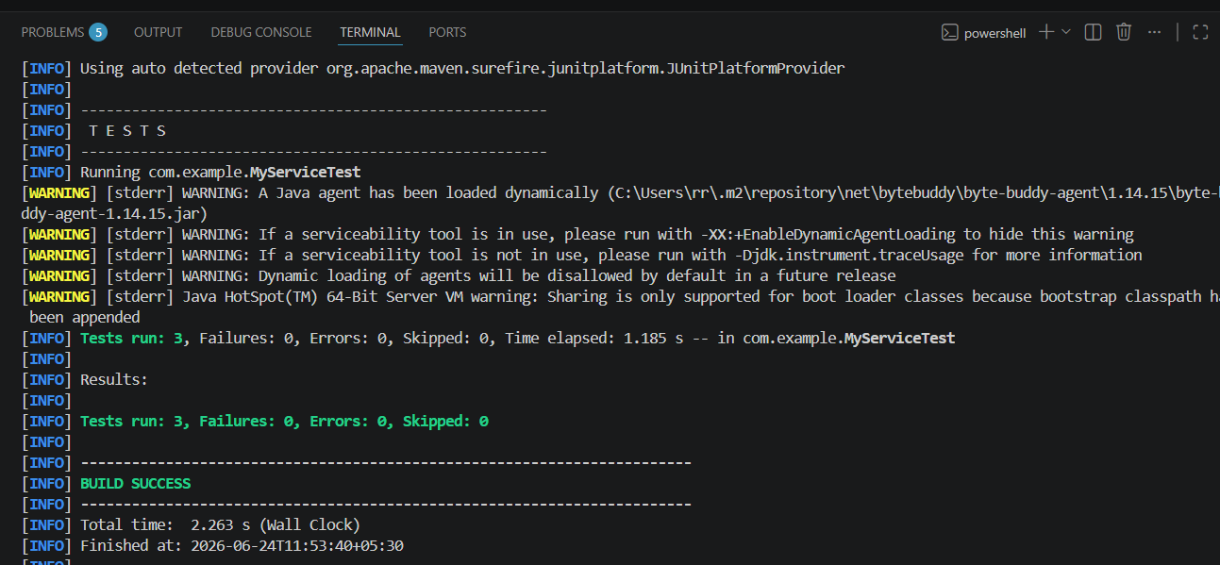

Exercise 4: Handling Void Methods
Output:
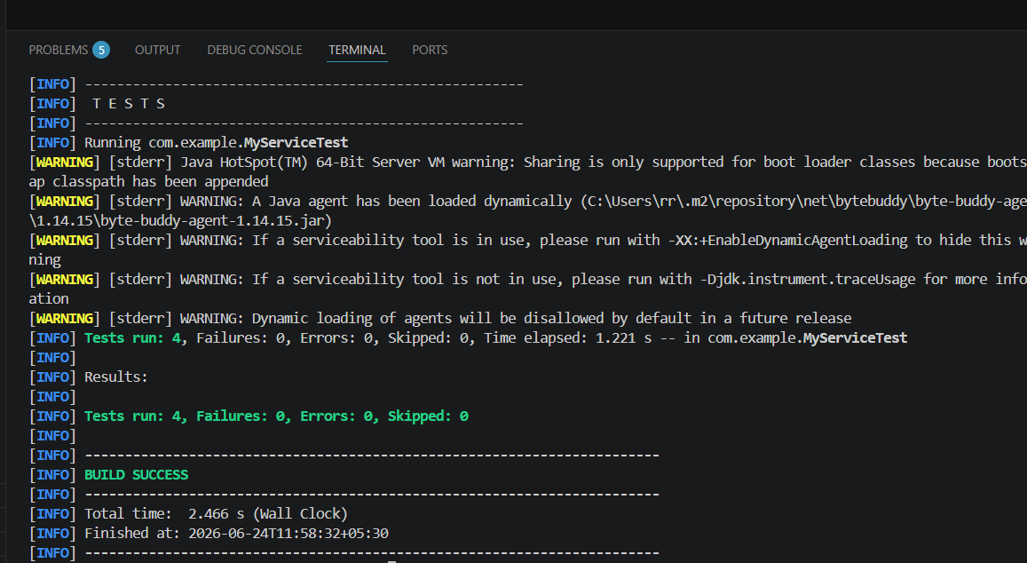

Exercise 5: Mocking and Stubbing with Multiple Returns
Output:
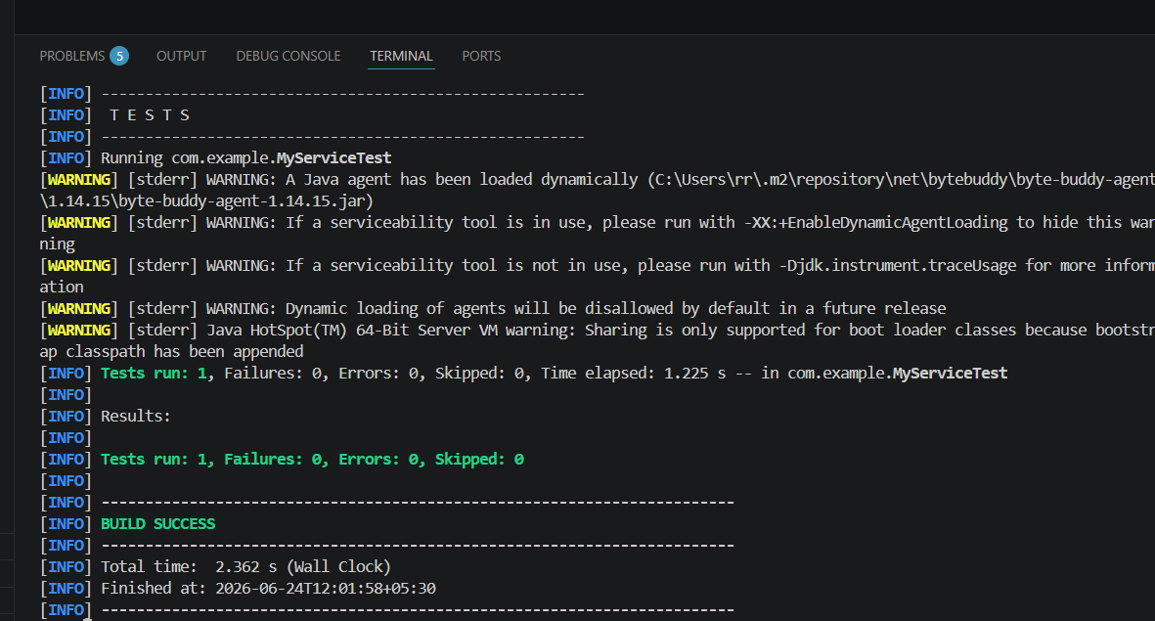

Exercise 6: Verifying Interaction Order
Output:
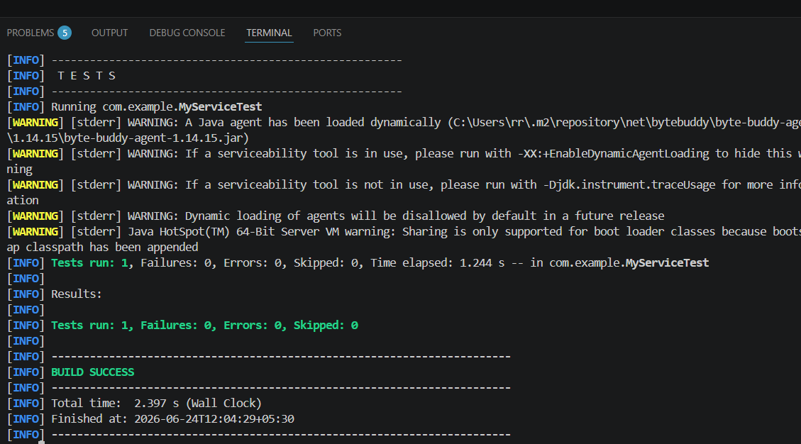

Exercise 7: Handling Void Methods with Exceptions
Output:
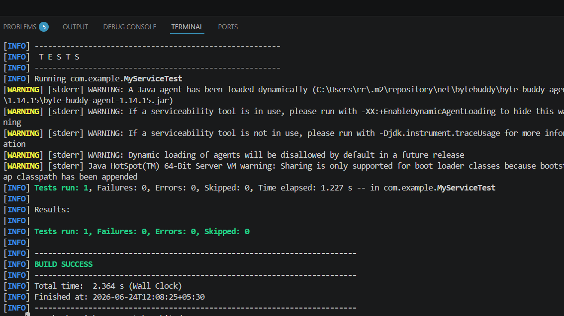

6) Logging using SLF4J
Exercise 1: Exercise 1: Logging Error Messages and Warning Levels
Pom.xml:
<dependencies>
<dependency>
<groupId>org.slf4j</groupId>
<artifactId>slf4j-api</artifactId>
<version>2.0.12</version> </dependency>
<dependency>
<groupId>ch.qos.logback</groupId>
<artifactId>logback-classic</artifactId>
<version>1.5.3</version> </dependency>
</dependencies>

LoggingExample.java:
package com.example;
import org.slf4j.Logger;
import org.slf4j.LoggerFactory;
public class LoggingExample {
private static final Logger logger = LoggerFactory.getLogger(LoggingExample.class);
public static void main(String[] args) {
System.out.println("--- Application Starting ---");
logger.error("This is an error message - Something went wrong!");
logger.warn("This is a warning message - Heads up, pay attention!");
logger.info("This is an info message - Just letting you know.");
}
}
Output:
